This is problem to convert all the negative coordinates to a positive coordinates;

The agenda is to get all the coordinates in 0 or positive values keeping the relative distance same;

We can add or delete any number from the coordinates ; however graph should not be changed;

Input: [(1,-2), (-2, 4), (-1,-1),(-8, -3), (0, 4), (10,-3)]

Output : [(9,6), (6, 12), (7,7),(0, 5), (8, 12), (18,5)]

**ANS:**

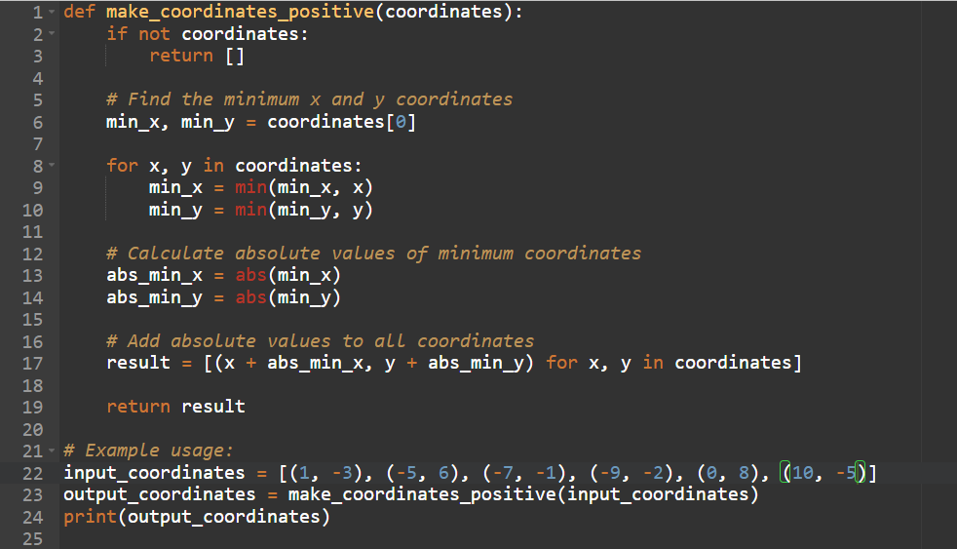

**OUTPUT:**

